SWOC 2017 – Component overview

In this document, an overview is given of the different components and how they work together to provide the challenge for the Sioux Weekend of Code 2017. If unfamiliar with the challenge, please have a look at <insert document here>.

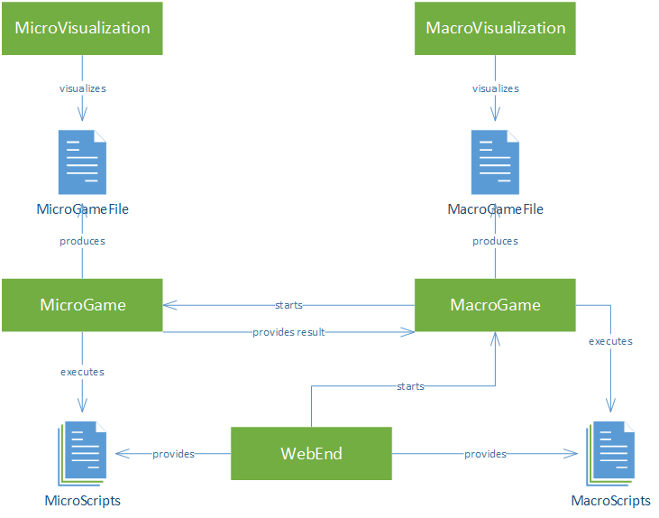

Figure 1: Overview of the different components

# MacroVisualization

MacroVisualization takes the file that MacroGame produces and uses it to visualize how a game played out. This file can contain the game state at every step, or whatever is necessary to produce the game state at every step such that it can be visualized.

# MacroGame

The MacroGame component provides an API for SWOC contestants to program their bots against. These bots are provided in the form of scripts by the FrontEnd and are executed by MacroGame. At every step, a script is provided some calculation time to come up with an action. These actions are executed resulting in a change of the game state, which is eventually written to a file that is used by MacroVisualization.

Whenever a battle is started in the game, MacroGame will start an instance of MicroGame. This component will provide it with the result of the battle.

# MicroVisualization

MicroVisualization takes the file that MicroGame produces and uses it to visualize how a game played out. This file can contain the game state at every step, or whatever is necessary to produce the game state at every step such that it can be visualized.

# MicroGame

The MicroGame component provides an API for SWOC contestants to program their bots against. These bots are provided in the form of scripts by the FrontEnd and are executed by MicroGame. At every step, a script is provided some calculation time to come up with an action. These actions are executed resulting in a change of the game state, which is eventually written to a file that is used by MicroVisualization.

MicroGames can only be started by a MacroGame.

# WebEnd

WebEnd provides a web interface that explains the game to the SWOC contestants. Here, they can create an account and upload their scripts. These scripts are then put into the right place, such that they can be executed by MacroGame and MicroGame.